IN615008:

Switching, Routing and Wireless Essentials

Assignment (40%)

Student Name: Jamie Robinson (08001072)

Due Date/Time: Friday 27 May

A 10% penalty will be applied for each day late.

Course credits: 15
Level: 6

Instructions

You are required to complete this assignment and submit a digital copy of this document, along with the Packet Tracer file of the completed network configuration. Your digital copy of this document should include the answers to all questions as indicated. The two files will need to be emailed to mholtz@op.ac.nz by the date/ time listed.

Learning Objectives

- Design and build a network for availability and redundancy.

- Configure and troubleshoot flexible local area networks using virtual and wireless technologies.

Background

Choam Corporation is redesigning its network to take advantage of a hierarchical network design and the performance and scalability benefits of OSPF. You have been requested to carry out the redesign and ensure it meets all specified requirements.

The physical topology has already been decided upon. You are required to made decisions about the logical topology and create the resulting network within Packet Tracer for testing purposes. Choam Corporation has also requested that you answer some questions pertaining to the design, the technologies employed and possible future direction.

Requirements

The network is to be comprised of a Head Office (HO) LAN that is connected to the internet and one additional remote WAN site. The HO LAN utilises a collapsed core architecture which combines both distribution and core layers.

HO Requirements

- 4 user VLANs (Finance, Sales, Personnel, Admin). Each user VLAN will have a maximum size of 30 usable IP addresses. Ensure these networks can be summarised in as small a contiguous block as possible.
- 1 server VLAN. The server VLAN will require a maximum of 12 usable IP addresses.
- Use private IP addressing from 10.15.15.0/24 unless otherwise specified.
- The company wishes to conserve IP Addresses where possible for future use. Therefore you must use VLSM for IP addressing.
- All HO switches require a management address within a dedicated management VLAN. The management network is a /28 IP network.
- OSPF will run between the WAN edge routers and between HO and Site2.
- Access and Distribution switches are layer 2 (2960) switches.
- You are required to decide upon a naming convention, for the network devices and the end hosts, that is logical and consistent.
- 4 servers in a dedicated VLAN will be connected to the same access switch.
- For the purpose of the packet tracer proof of concept, only 1 PC per user VLAN is required on each of the non-server switches.
- Further requirements are outlined in each section below.

Site-2 Requirements

- Use private addressing from 10.16.16.0/24 unless otherwise specified.
- 4 employees in the Site2 Finance department.
- 15 employees in the Site2 Sales department.
- All switches require a management address allocated from within the appropriate employee VLAN (no dedicated management VLAN required).
- You must use VLSM for IP address allocation.
- All switches are Layer 2 switches.
- You are required to decide upon a naming convention, for the network devices and the end hosts, that is logical and consistent.
- There are no servers located in Site2.
- Further requirements are outlined in each section below.

IP address assignment

- All PCs will be dynamically assigned IP addresses.
- All other IP addresses will be statically assigned.

Network Topology

The physical topology is shown here. Link status indicators are not accurate as the devices shown are not configured.

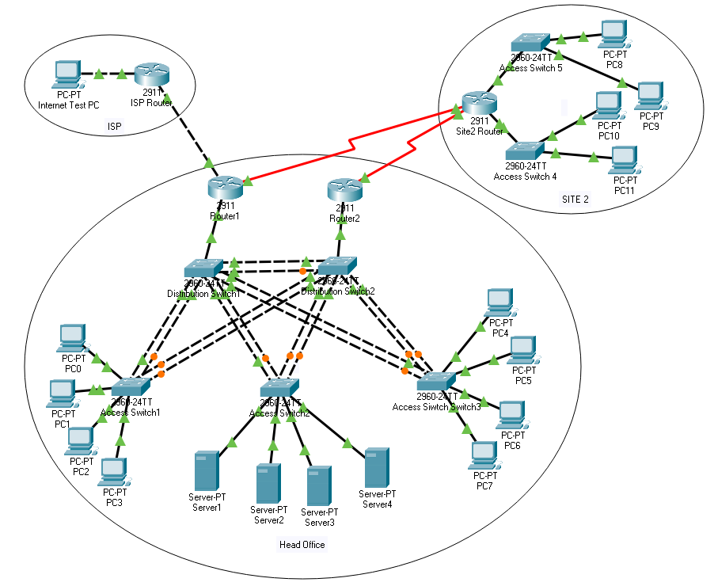

Section One: Document Logical Design [21 marks]

- You are required to produce documentation (use tables, See the Appendix for example templates.) for the following:

- All device names
- Interface addressing (all statically assigned addresses of routers, switches and servers)
- VLAN interface assignment [6 marks]

- You are required to produce documentation (use tables, See the Appendix for example templates.) for the following:

- All IP Networks (include Network IP, Default Gateway, Broadcast, Max usable hosts, mask, purpose). Note you will need to perform subnetting as required to create the required number of networks outlined in the above specifications. [15 marks]

Section Two: Head Office LAN [63 marks]

- Cable 3 access layer switches and 2 distribution switches (all are 2960 Layer switches). Ensure the access switches are cabled to each distribution switch. Ensure the distribution switches are cabled to each other. Ensure an adequate number of cables are used to facilitate etherchannel in step 9. [5 marks]
- Ensure the switches are correctly configured with a hostname, management address and default gateway. [5 marks]
- Configure the LAN for Rapid-PVST+. Configure the 4 User VLANs, Server VLAN and a Management VLAN. Choose and configure a switch to be the root bridge for the 4 User VLANs and the second switch to be root for the remaining VLANs. Choose and configure secondary root bridges for each VLAN. [15 marks]
- Describe how the root bridge, designated ports and root ports would be determined by default. Provide captured output to confirm the root bridge in your topology. [10 marks]
A root bridge is selected amongst switches via a Root Bridge Election. An election winner will be selected if it has the lowest value from the available bridge priority values from the Bridge ID. The default value is 32768, if all values are equal e.g., all bridges have the same default value, then a switch with the lowest MAC address will be elected as the root bridge.
Bridge Protocol Data Units (BDPUs) are units that are sent between switches to share information e.g., Bridge IDs. They also contain path cost information. Using the path cost information, the best path (lowest cost) to the root bridge is identified. From this cost, the root port is assigned, the root port is the closest port to the root bridge in terms of cost on a non-root bridge switch.
Ports that are not root ports on a switch become either designated ports or alternate/blocked ports. The designated port has the best path to receive traffic leading to the root bridge. A root bridge’s ports are all designated ports. All remaining ports on the switches become alternate/blocked ports. These ports are unused until a link fails and then they may become a designated port or root port.
The Root Bridge for User VLANs & Secondary Root for the remaining VLANs is Head Office Distribution Switch 1. Root Bridge for default, Servers & Management VLANs, secondary root for user VLANs is Head Office Distribution Switch 2.
Head Office Distribution Switch 1
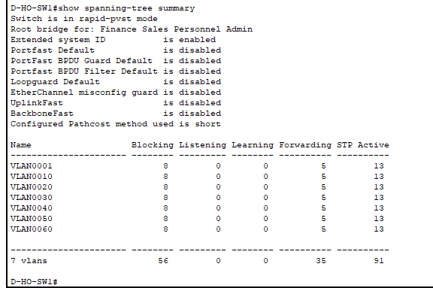
Head Office Distribution Switch 2
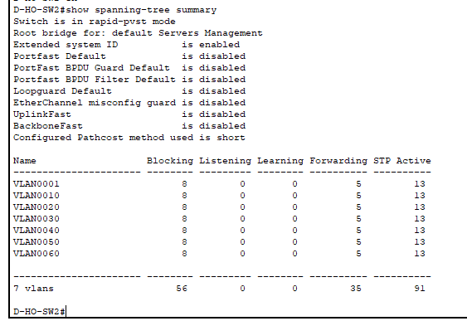
- Cable and configure at least 1 PC per User VLAN on two of the access switches. The PC IP addressing is dynamic. [2 marks]
- Cable and configure 4 servers in the Server VLAN on the remaining access switch. Use static IP addressing. [4 marks]
- Ensure all appropriate ports have port-fast configured. What is the purpose of this command? [5 Marks]
Configuring port-fast on specific ports allows ports to bypass transition states (listening and learning) and allows the ports to go from blocking to forwarding immediately. This skips the 30 second delay (15 seconds for each state) that would occur if it was not configured. This means that when port-fast is configured ports connected to end devices those devices can access the network faster.
- Ensure all appropriate ports have BPDU-guard configured. What is the purpose of this command? [5 marks]
Configuring a BPDU guard on switch ports connected to end devices stops BDPUs from being received on ports that have port-fast configured. It puts the ports in an error-disabled state when receiving a BDPU which effectively shuts down the port against them. This should not be configured on ports connected to other switches as it may cause a spanning tree loop.
- Implement PAgP and 802.1q trunking between the two distribution switches ensuring at least 2 physical cables are used. Implement LACP and 802.1q trunking between each of the access switches and distribution switches (2 physical links per channel). In your documentation provide captured output showing which ports have been aggregated and the type of aggregation (for all port channels). [12 marks]
Head Office Distribution Switch 1
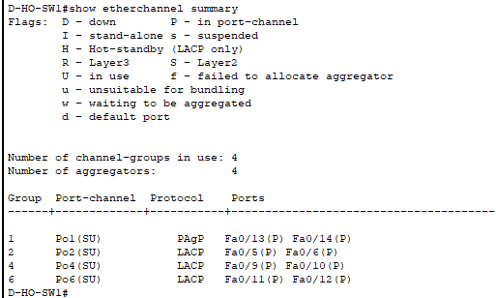

Head Office Distribution Switch 2
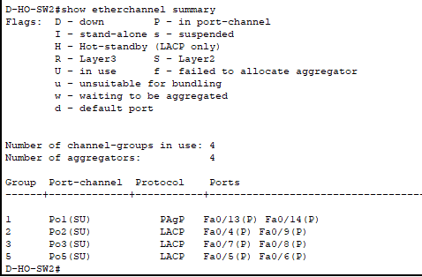
Head Office Access Switch 1
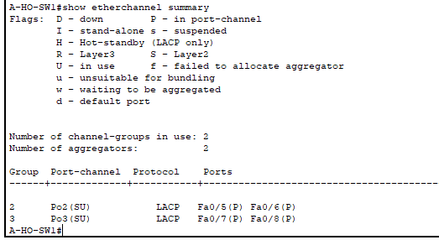

Head Office Access Switch 2
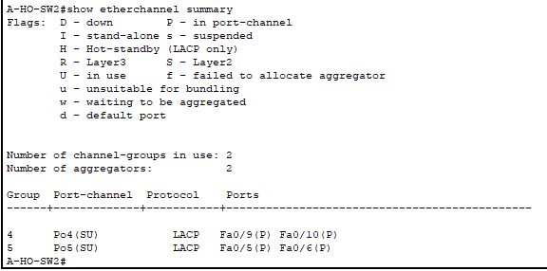
Head Office Access Switch 3
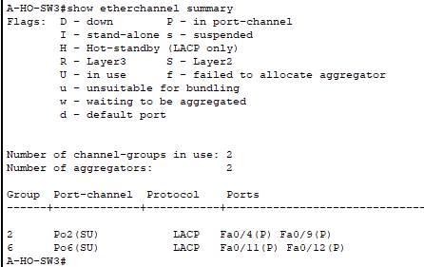

Section Three: Head Office Routing [58 marks]

- Add 2 head office routers. Each router is cabled to a different distribution switch. Ensure the HO routers are configured with a hostname, logging synchronous, no ip domain lookup & SSH access (including admin user). [5 marks]

- Configure each Router for inter VLAN routing using ROAST. [10 marks]

- Configure HSRP for each VLAN. Ensure that the active gateway is connected to the root bridge for that VLAN. [10 marks]

- Ensure pre-emption is supported. Document what this does. [5 marks]

Pre-emption in HSRP forces a new election process to take place every time a new router comes online within the network. This ensures that the router with the highest priority will always be the active router. Without pre-emption being enabled, the router that boots up first within a network will be the default active router until an election takes place.

- Show capture output that displays the standby status on both HO routers. [4 marks]

Head Office Router 1

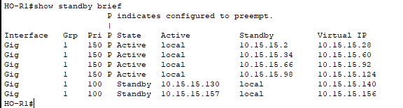

Head Office Router 2

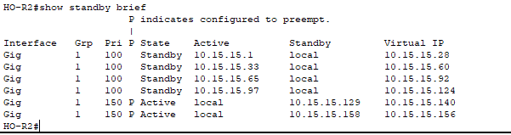

- Configure OSPF AERA 0 on each router for the HO VLAN networks. Ensure Router-IDs are configured. [10 marks]

- Research the function of DR & BDR roles within OSPF. Explain why they exist and the default process for DR election. Ensure one router is manually configured to be a DR for all its OSPF adjacencies. Provide capture output evidence showing the correct DR relationship for the OSPF adjacencies. [14 marks]

DR stands for Designated Router, BDR stands for Backup Designated Router, they act as the key point for exchanging OSPF (Open Shortest Path First) information within a network segment. Having a DR and BDR limits the amount of information sent by non-DRs and non-BDRs. This is done by non-DRs and non-BDRs only exchanging routing information with the DR and BDR. This reduces the amount of routing updates being sent across the segment. If not manually configured, the default process for each segment for DR and BDR selection is the router with the highest priority, the default is 1. If two or more routers have the same priority, then the router with the highest router ID is selected.

Head Office Router 1

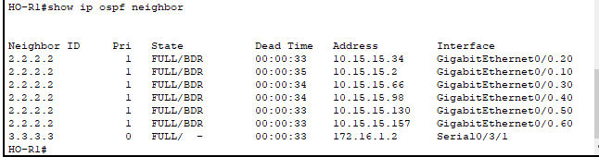

Head Office Router 2

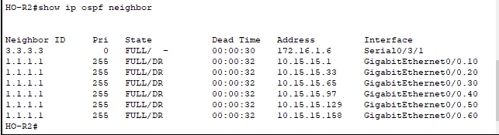

Section Four: Site2 LAN [17 marks]

- Cable 2 access layer switches to the Site2 router (2960 switches). Cable 2 PCs to each Site2 access switch [2 marks]
- Ensure the Site2 switches are correctly configured with a hostname, management address and default gateway. [2 marks]
- Configure the Finance VLAN on one switch and configure Sales on the other. [2 marks]
- Configure 2 PCs per User VLAN. The PC IP addressing is dynamic. [2 marks]
- Configure legacy inter VLAN routing on the Site2 router. [5 marks]
- Configure switchport security for all Site2 switchports connected to PCs. Each port is to allow only 2 dynamically learned MAC addresses. These are to be auto populated into the running-config. Ensure there is a notification if a violation occurs. [4 marks]

Section Five: WAN [24 marks]

- Cable and configure two serial links between HO LAN and the Site2 router. Ensure the clock rate is set to 128000. Use the following IP networks for the serial links: 172.16.1.0/30 & 172.16.1.4/30. [2 marks]

- Configure OSPF area 1 for the WAN links between the HO Routers and the Site2 routers. Ensure router IDs are configured. Show output evidence confirming the OSPF adjacency is operational. [6 marks]

Site 2 Router 1

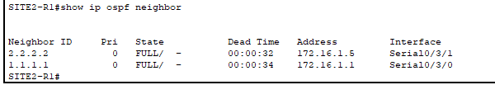

- Configure the Site2 router to advertise connected VLAN networks via OSPF. Ensure OSPF packets are not sent over LAN interfaces in site2. [6 marks]

- Configure HO Router2 connected to Site2 to advertise a single OSPF summary address representing the Site2 VLAN networks. Provide evidence output of this being visible on the other HO Router1 (connected to the ISP). [5 marks]’

Head Office Router 1

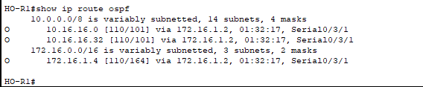

- Configure OSPF such that the Head Office Router 2 is the preferred path to and from Site2. [5 marks]

Section Six: DHCP [17 marks]

- Configure DHCP on HO Router2 connected to Site2 to support the 4 HO User VLANs and the 2 Site2 User VLANs. Ensure to exclude addresses that have already been allocated from each subnet to servers and gateways. [8 marks]

- Configure the Site2 router to allow Site2 PCs to obtain IP addresses from the HO router. [3 marks]

- Document output from the HO Router2 confirming DHCP leases for HO and Site2. [3 marks]

Head Office Router 2

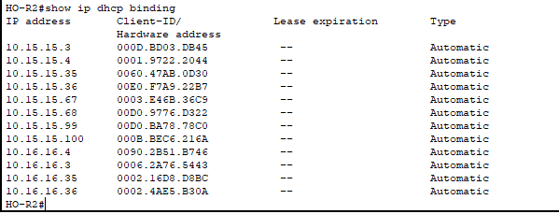

- Explain the difference between stateless and stateful DHCPv6. [3 marks]

A stateless DHCPv6 server does not provide IP addresses, instead it gives all other information to its’ hosts, such as DNS server lists and domain names. Stateless means that there is no server keeping track of assigned and non-assigned addresses.

A stateful DHCPv6 server will give their hosts IP addresses and other information. A stateful DHCPv6 server keeps track of the IPs assigned, non-assigned IPs and IPs that have been excluded from the address pools.

Section Seven: Internet Routing [10 marks]

- Cable ISP router to HO Router1. Configure the ISP router with a hostname. Configure the link between the HO router and the ISP router using the 192.168.1.0/30 network, ensure the ISP end uses the first available IP. [2 marks]

- Configure a static default route on HO Router1 pointing to the IP address assigned to the ISP router end of the link. Advertise the static using OSPF. [4 marks]

- Configure a static route on the ISP router for a summary IP network address representing the HO LAN networks pointing to the outbound interface facing HO. [2 marks]

- Configure the internet test host directly connected to the ISP router. The host uses the IP address of 209.100.100.3/29, the ISP router interface connected to the PC uses 209.100.100.1/29. [2 marks]

Section Eight: Testing / Final Connectivity [10 marks]

- Test that you can ping from a PC within each Head Office and Site2 VLAN to a PC in each other HO and Site2 VLAN. Test that a PC in each user VLAN can ping a Server. Test that HO LAN PCs and Servers can ping the internet PC. If any pings fail then troubleshoot as necessary to resolve the issues. Provide a table of your results. If any pings are still failing then describe what is happening and why you think it is happening. [10 marks]

Section Nine: Formatting [10 marks]

- Ensure your packet tracer network diagram is commented and supporting documentation is formatted neatly and comprehensible. [10 marks]

Assignment of Marks

You will be assigned marks as follows:-

- Total Marks available 230 marks
Section | Topic | Mark
Section One | Logical Design | 21
Section Two | HO LAN | 63
Section Three | HO Routing | 58
Section Four | Site2 LAN | 17
Section Five | WAN | 24
Section Six | DHCP | 17
Section Seven | Internet Routing | 10
Section Eight | Testing | 10
Section Nine | Formatting | 10

Documentation – Network Information

HQ – Network Summary
Network Name | VLAN | Number of host addresses required | Network Address | Subnet Mask | Max Number of Hosts Possible | Assignable Range | Gateway Address
Finance | 10 | 30 | 10.15.15.0 | 255.255.255.224 | 30 | 10.15.15.1 - 10.15.15.30 | 10.15.15.1
Sales | 20 | 30 | 10.15.15.32 | 255.255.255.224 | 30 | 10.15.15.33 - 10.15.15.62 | 10.15.15.33
Personnel | 30 | 30 | 10.15.15.64 | 255.255.255.224 | 30 | 10.15.15.65 - 10.15.15.94 | 10.15.15.65
Admin | 40 | 30 | 10.15.15.96 | 255.255.255.224 | 30 | 10.15.15.97 - 10.15.15.126 | 10.15.15.97
Servers | 50 | 12 | 10.15.15.128 | 255.255.255.240 | 14 | 10.15.15.129 - 10.15.15.142 | 10.15.15.129
Management | 60 | 5 | 10.15.15.144 | 255.255.255.240 | 14 | 10.15.15.145 - 10.15.15.158 | 10.15.15.158

Site 2 – Network Summary
Network Name | VLAN | Number of host addresses required | Network Address | Subnet Mask | Max Number of Hosts Possible | Assignable Range | Gateway Address
Site2Finance | 70 | 5 | 10.16.16.0 | 255.255.255.248 | 6 | 10.16.16.1 - 10.16.16.6 | 10.16.16.1
Site2Sales | 80 | 15 | 10.16.16.32 | 255.255.255.224 | 30 | 10.16.16.33 - 10.16.16.62 | 10.16.16.33

HQ Router1 Name: HO-R1
Interface/Sub Interface | Network Name | Description and Purpose | Network Address | Interface IP Address | Subnet Mask
G0/0.10 | Finance | VLAN 10 Sub | 10.15.15.0 | 10.15.15.1 | 255.255.255.224
G0/0.20 | Sales | VLAN 20 Sub | 10.15.15.32 | 10.15.15.33 | 255.255.255.224
G0/0.30 | Personnel | VLAN 30 Sub | 10.15.15.64 | 10.15.15.65 | 255.255.255.224
G0/0.40 | Admin | VLAN 40 Sub | 10.15.15.96 | 10.15.15.97 | 255.255.255.224
G0/0.50 | Servers | VLAN 50 Sub | 10.15.15.128 | 10.15.15.129 | 255.255.255.240
G0/0.60 | Management | VLAN 60 Sub | 10.15.15.144 | 10.15.15.158 | 255.255.255.240
S0/3/1 | WAN Serial | Site2-R1 Link | 172.16.1.0 | 172.16.1.1 | 255.255.255.252
G0/1 | ISP | ISP-R1 Link | 192.168.1.0 | 192.168.1.2 | 255.255.255.252

HQ Router2 Name: HO-R2
Interface/Sub Interface | Network Name | Description and Purpose | Network Address | Interface IP Address | Subnet Mask
G0/0.10 | Finance | VLAN 10 Sub | 10.15.15.0 | 10.15.15.2 | 255.255.255.224
G0/0.20 | Sales | VLAN 20 Sub | 10.15.15.32 | 10.15.15.34 | 255.255.255.224
G0/0.30 | Personnel | VLAN 30 Sub | 10.15.15.64 | 10.15.15.66 | 255.255.255.224
G0/0.40 | Admin | VLAN 40 Sub | 10.15.15.96 | 10.15.15.98 | 255.255.255.224
G0/0.50 | Servers | VLAN 50 Sub | 10.15.15.128 | 10.15.15.130 | 255.255.255.240
G0/0.60 | Management | VLAN 60 Sub | 10.15.15.144 | 10.15.15.157 | 255.255.255.240
S0/3/1 | WAN Serial | Site2-R1 Link | 172.16.1.4 | 172.16.1.5 | 255.255.255.252

Site2 Router Name: SITE2-R1
Interface/Sub Interface | Network Name | Description and Purpose | Network Address | Interface IP Address | Subnet Mask
G0/1 | Site2Finance | VLAN 70 Int | 10.16.16.0 | 10.16.16.1 | 255.255.255.248
G0/0 | Site2Sales | VLAN 80 Int | 10.16.16.32 | 10.16.16.33 | 255.255.255.224
S0/3/0 | WAN Serial | HO-R1 Link | 172.16.1.0 | 172.16.1.2 | 255.255.255.252
S0/3/1 | WAN Serial | HO-R2 Link | 172.16.1.4 | 172.16.1.6 | 255.255.255.252

ISP Router Name: ISP-R1
Interface/Sub Interface | Network Name | Description and Purpose | Network Address | Interface IP Address | Subnet Mask
G0/0 | Internet PC | Link to PC | 209.100.100.0 | 209.100.100.1 | 255.255.255.248
G0/1 | Head Office | Link to HO-R1 | 192.168.1.0 | 192.168.1.1 | 255.255.255.252

HQ Distribution Switch1 Name: D-HO-SW1
Switch Mgmt IP address: 10.15.15.148 VLAN: 60
Port/Number | Description and Purpose | Trunk / Access | VLAN / VLANs allowed
G0/1 | Link to R1 | Trunk | 60/1,10,20,30,40,50,60
Port-Channel1 | Ether Channel | Trunk | 60/1,10,20,30,40,50,60
Port-Channel2 | Ether Channel | Trunk | 60/1,10,20,30,40,50,60
Port-Channel4 | Ether Channel | Trunk | 60/1,10,20,30,40,50,60
Port-Channel6 | Ether Channel | Trunk | 60/1,10,20,30,40,50,60
Fa0/5, Fa0/6 | Channel Group 2 | Trunk | 60/1,10,20,30,40,50,60
Fa0/9, Fa0/10 | Channel Group 4 | Trunk | 60/1,10,20,30,40,50,60
Fa0/11, Fa0/12 | Channel Group 6 | Trunk | 60/1,10,20,30,40,50,60
Fa0/13, Fa0/14 | Channel Group 1 | Trunk | 60/1,10,20,30,40,50,60

HQ Distribution Switch2 Name: D-HO-SW2
Switch Mgmt IP address: 10.15.15.149 VLAN: 60
Port/Number | Description and Purpose | Trunk / Access | VLAN / VLANs allowed
G0/1 | Link to R2 | trunk | 60/1,10,20,30,40,50,60
Port-Channel1 | Ether Channel | Trunk | 60/1,10,20,30,40,50,60
Port-Channel2 | Ether Channel | Trunk | 60/1,10,20,30,40,50,60
Port-Channel3 | Ether Channel | Trunk | 60/1,10,20,30,40,50,60
Port-Channel5 | Ether Channel | Trunk | 60/1,10,20,30,40,50,60
Fa0/4, Fa0/9 | Channel Group 2 | Trunk | 60/1,10,20,30,40,50,60
Fa0/5, Fa0/6 | Channel Group 5 | Trunk | 60/1,10,20,30,40,50,60
Fa0/7, Fa0/8 | Channel Group 3 | Trunk | 60/1,10,20,30,40,50,60
Fa0/13, Fa0/14 | Channel Group 1 | Trunk | 60/1,10,20,30,40,50,60

HQ Access Switch1 Name: A-HO-SW1
Switch IP address: 10.15.15.145 VLAN: 60
Port/Number | Description and Purpose | Trunk / Access | VLAN / VLANs allowed
Fa0/1 | PC1 VLAN10 Link | Access | 10
Fa0/2 | PC2 VLAN20 Link | Access | 20
Fa0/3 | PC3 VLAN30 Link | Access | 30
Fa0/4 | PC4 VLAN40 Link | Access | 40
Port-Channel3 | Ether Channel | Trunk | 60/1,10,20,30,40,50,60
Port-Channel2 | Ether Channel | Trunk | 60/1,10,20,30,40,50,60
Fa0/5, Fa0/6 | Channel Group 2 | Trunk | 60/1,10,20,30,40,50,60
Fa0/7, Fa0/8 | Channel Group 3 | Trunk | 60/1,10,20,30,40,50,60

HQ Access Switch2 Name: A-HO-SW2
Switch IP address: 10.15.15.146 VLAN: 60
Port/Number | Description and Purpose | Trunk / Access | VLAN / VLANs allowed
Fa0/1 | Server1 VLAN50 Link | Access | 50
Fa0/2 | Server2 VLAN50 Link | Access | 50
Fa0/3 | Server3 VLAN50 Link | Access | 50
Fa0/4 | Server4 VLAN50 Link | Access | 50
Port-Channel4 | Ether Channel | Trunk | 60/1,10,20,30,40,50,60
Port-Channel5 | Ether Channel | Trunk | 60/1,10,20,30,40,50,60
Fa0/9, Fa0/10 | Channel Group 4 | Trunk | 60/1,10,20,30,40,50,60
Fa0/5, Fa0/6 | Channel Group 5 | Trunk | 60/1,10,20,30,40,50,60

HQ Access Switch3 Name: A-HO-SW3
Switch IP address: 10.15.15.147 VLAN: 60
Port/Number | Description and Purpose | Trunk / Access | VLAN / VLANs allowed
Fa0/5 | PC5 VLAN10 Link | Access | 10
Fa0/6 | PC6 VLAN20 Link | Access | 20
Fa0/7 | PC7 VLAN30 Link | Access | 30
Fa0/8 | PC8 VLAN40 Link | Access | 40
Port-Channel6 | Ether Channel | Trunk | 60/1,10,20,30,40,50,60
Port-Channel2 | Ether Channel | Trunk | 60/1,10,20,30,40,50,60
Fa0/4, Fa0/9 | Channel Group 2 | Trunk | 60/1,10,20,30,40,50,60
Fa0/11, Fa0/12 | Channel Group 6 | Trunk | 60/1,10,20,30,40,50,60

Site2 Access Switch1 Name: SITE2-SW1
Switch IP address:10.16.16.2 VLAN:70
Port/Number | Description and Purpose | Trunk / Access | VLAN / VLANs allowed
Fa0/1 | PC9 VLAN70 Link | Access | 70
Fa0/2 | PC10 VLAN70 Link | Access | 70
G0/1 | Link to Site2-R1 | Access | 70

Site2 Access Switch2 Name: SITE2-SW2
Switch IP address:10.16.16.34 VLAN:80
Port/Number | Description and Purpose | Trunk / Access | VLAN / VLANs allowed
Fa0/1 | PC11 VLAN80 Link | Access | 80
Fa0/2 | PC12 VLAN80 Link | Access | 80
G0/1 | Link to Site2-R1 | Access | 80

Static Server Addresses
Server Name | IP address | Subnet Mask | Gateway
Server1 | 10.15.15.133 | 255.255.255.240 | 10.15.15.129
Server2 | 10.15.15.134 | 255.255.255.240 | 10.15.15.129
Server3 | 10.15.15.135 | 255.255.255.240 | 10.15.15.129
Server4 | 10.15.15.136 | 255.255.255.240 | 10.15.15.129

Ping Tests

SOURCE | DESTINATION | RESULT | REASON (IF FAILED)
PC1 (HO) VLAN10 | Internet Test PC | Success
PC2 (HO) VLAN20 | PC12 (Site 2) VLAN80 | Success
PC3 (HO) VLAN30 | PC10 (Site 2) VLAN70 | Success
PC4 (HO) VLAN40 | PC8 (HO) VLAN40 | Success
PC5 (HO) VLAN10 | Server1 (HO) VLAN50 | Success
PC6 (HO) VLAN20 | Internet Test PC | Success
PC7 (HO) VLAN30 | PC9 (Site2) VLAN70 | Success
PC8 (HO) VLAN40 | PC11 (Site2) VLAN80 | Success
PC9 (Site 2) VLAN70 | Internet Test PC | Success
PC10 (Site 2) VLAN70 | Server2 (HO) VLAN50 | Success
PC11 (Site 2) VLAN80 | PC2 (HO) VLAN20 | Success
PC12 (Site 2) VLAN80 | PC5 (HO) VLAN10 | Success
Server1 (HO) VLAN50 | Internet Test PC | Success
Server2 (HO) VLAN50 | PC7 (HO) VLAN 30 | Success
Server3 (HO) VLAN50 | PC12 (Site2) VLAN80 | Success
Server4 (HO) VLAN50 | PC10 (Site2) VLAN70 | Success
Internet Test PC | PC3 (HO) VLAN30 | Success

PC1 (HO) VLAN10 | PC11 (Site2) VLAN80 | Success
PC2 (HO) VLAN20 | Server4 (HO) VLAN50 | Success
PC3 (HO) VLAN30 | Server3 (HO) VLAN50 | Success
PC4 (HO) VLAN40 | Server2 (HO) VLAN50 | Success
PC5 (HO) VLAN10 | PC12 (Site2) VLAN80 | Success
PC6 (HO) VLAN20 | PC10 (Site 2) VLAN70 | Success
PC7 (HO) VLAN30 | Internet Test PC | Success
PC8 (HO) VLAN40 | PC9 (Site 2) VLAN70 | Success
PC9 (Site 2) VLAN70 | Server1 (HO) VLAN50 | Success
PC10 (Site 2) VLAN70 | PC3 (HO) VLAN30 | Success
PC11 (Site 2) VLAN80 | Internet Test PC | Success
PC12 (Site 2) VLAN80 | PC8 (HO) VLAN40 | Success
Server1 (HO) VLAN50 | PC2 (HO) VLAN20 | Success
Server2 (HO) VLAN50 | PC9 (Site2) VLAN70 | Success
Server3 (HO) VLAN50 | PC1 (HO) VLAN10 | Success
Server4 (HO) VLAN50 | PC6 (HO) VLAN20 | Success
Internet Test PC | PC10 (Site2) VLAN70 | Success

